GroupAssignment Mastery Assignment
Error log
Stefan S
CSE 2110 Procedural Programming 1
(GroupAssignment.java)
Describe the errors you’ve encountered while working on this assignment. What caused the error and how do you overcome the error?

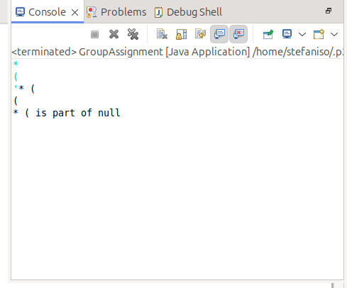
For the first version of the program, I inputted a last name which would not map to a key in the dictionary. This was to test how it would respond. I added an if-else statement to handle this.
